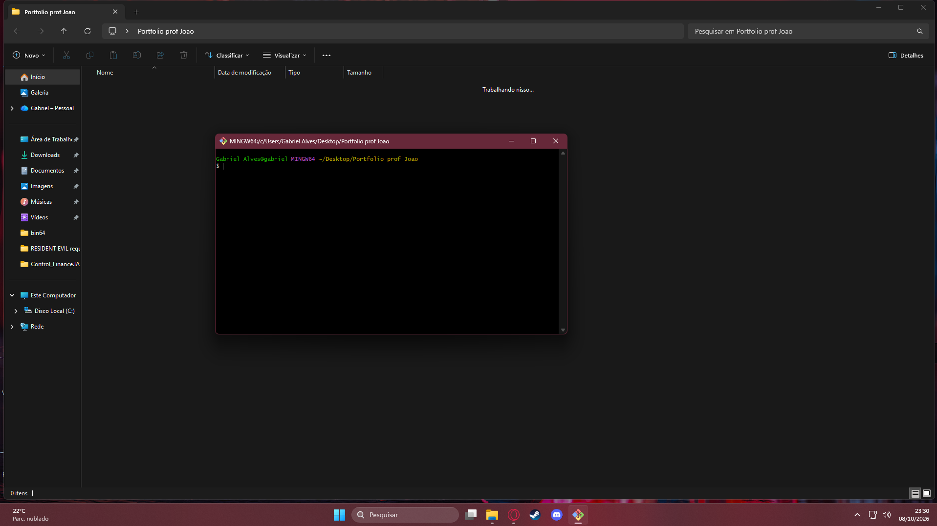

https://github.com/alvesszy/Meu-Portfolio

Wireframe: 
TELA INICIAL

